Nalini Chawla: BSc(Hons) Internet computing
Supervisor : Jim Wood
Introduction
I am designing and developing an interactive website aimed at weight-loss. This is dynamic and AJAX based and produces an exercise suggestions list based on the weight to lose and time to lose weight entered.

Design and development

Initially I designed the website on paper with pencil and no colours. Then I went to Serif Draw Plus to add colour and smarten the designs up. Then I used BestAddress(HTML WYSIWYG editor) to make the website first page including text boxes and texts. I used BestAddress to give me a basic idea of the raw HTML I need to deploy in my Dhtml application. The rough pencil drawings are shown below.(They are rough, but understandable by me).

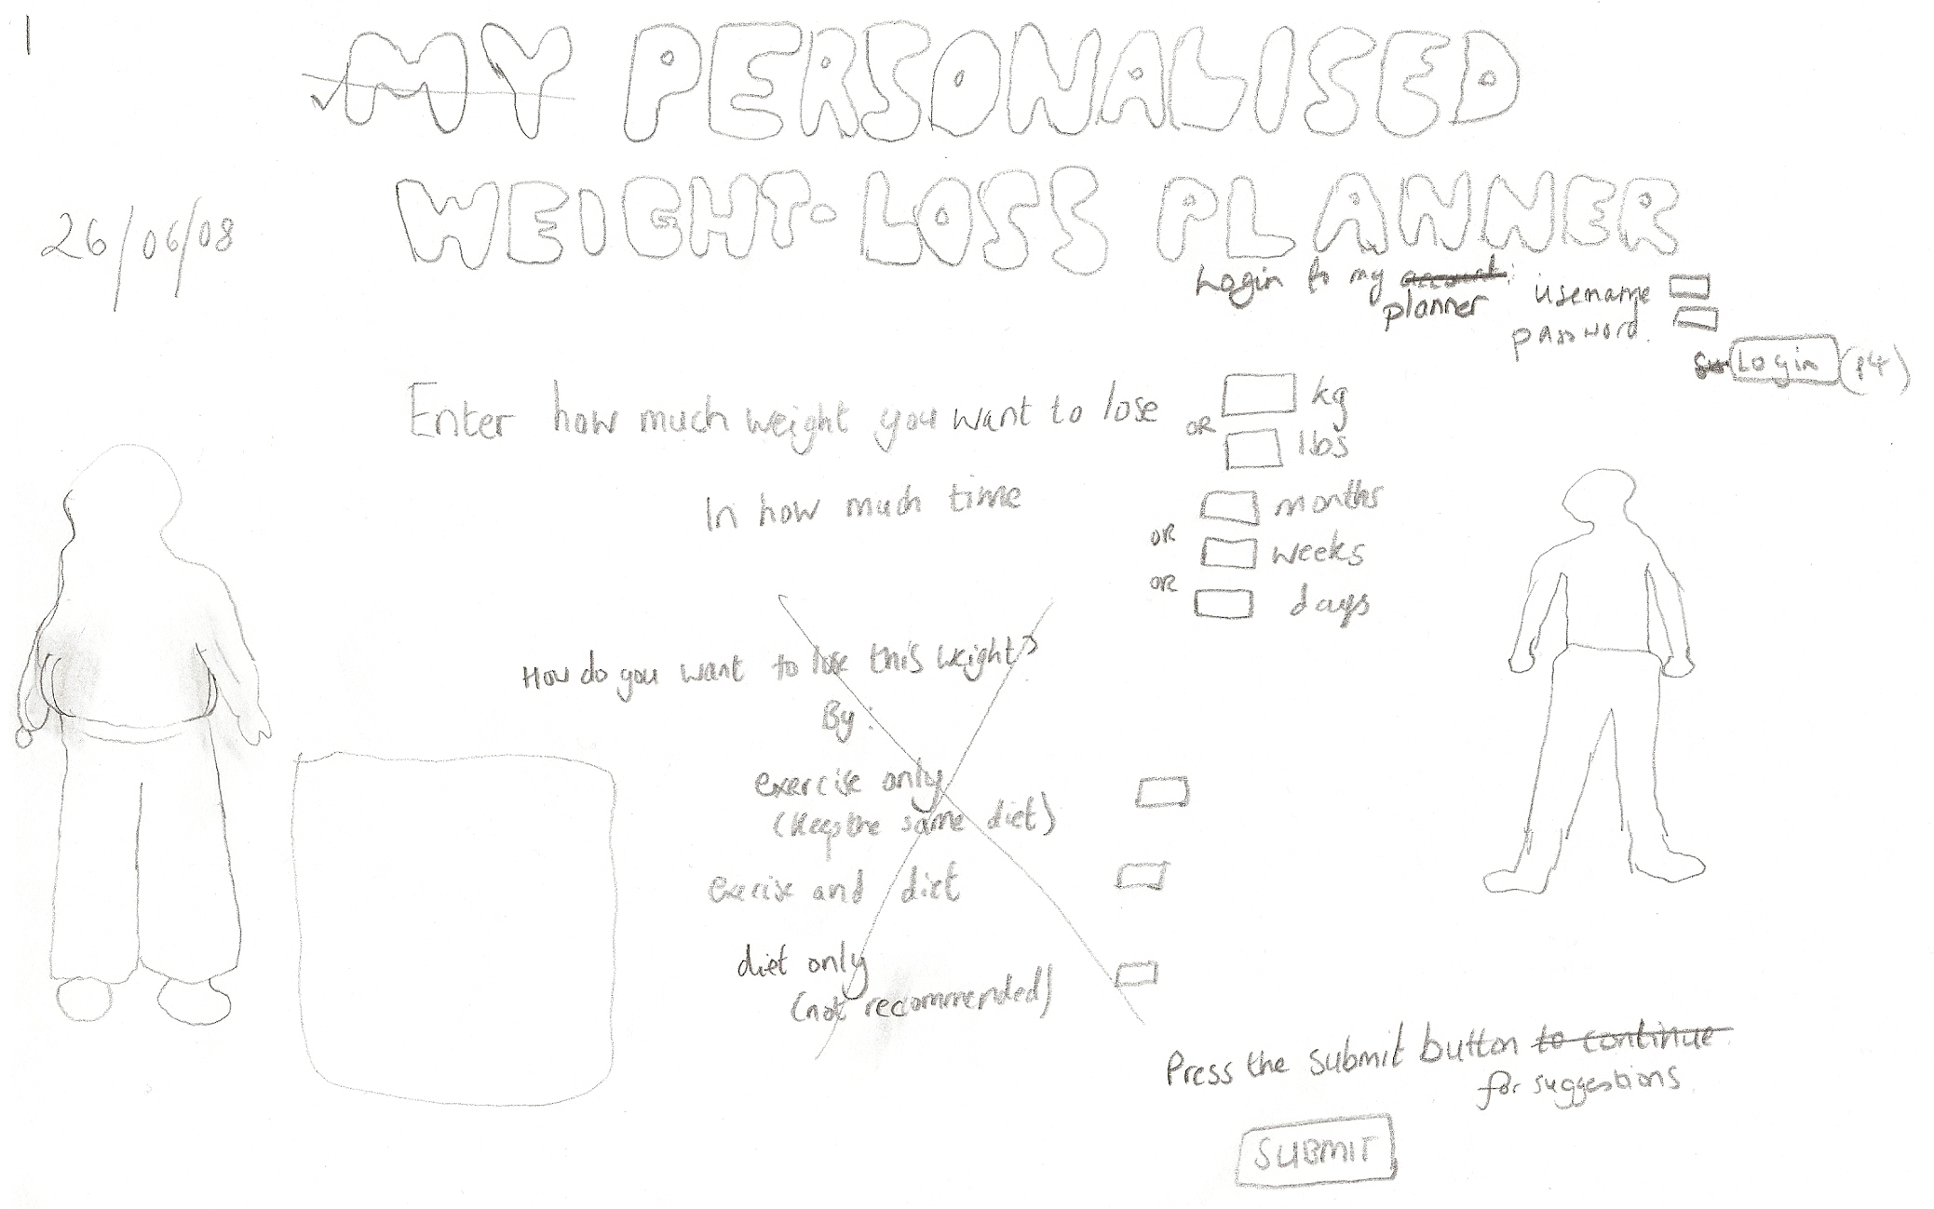

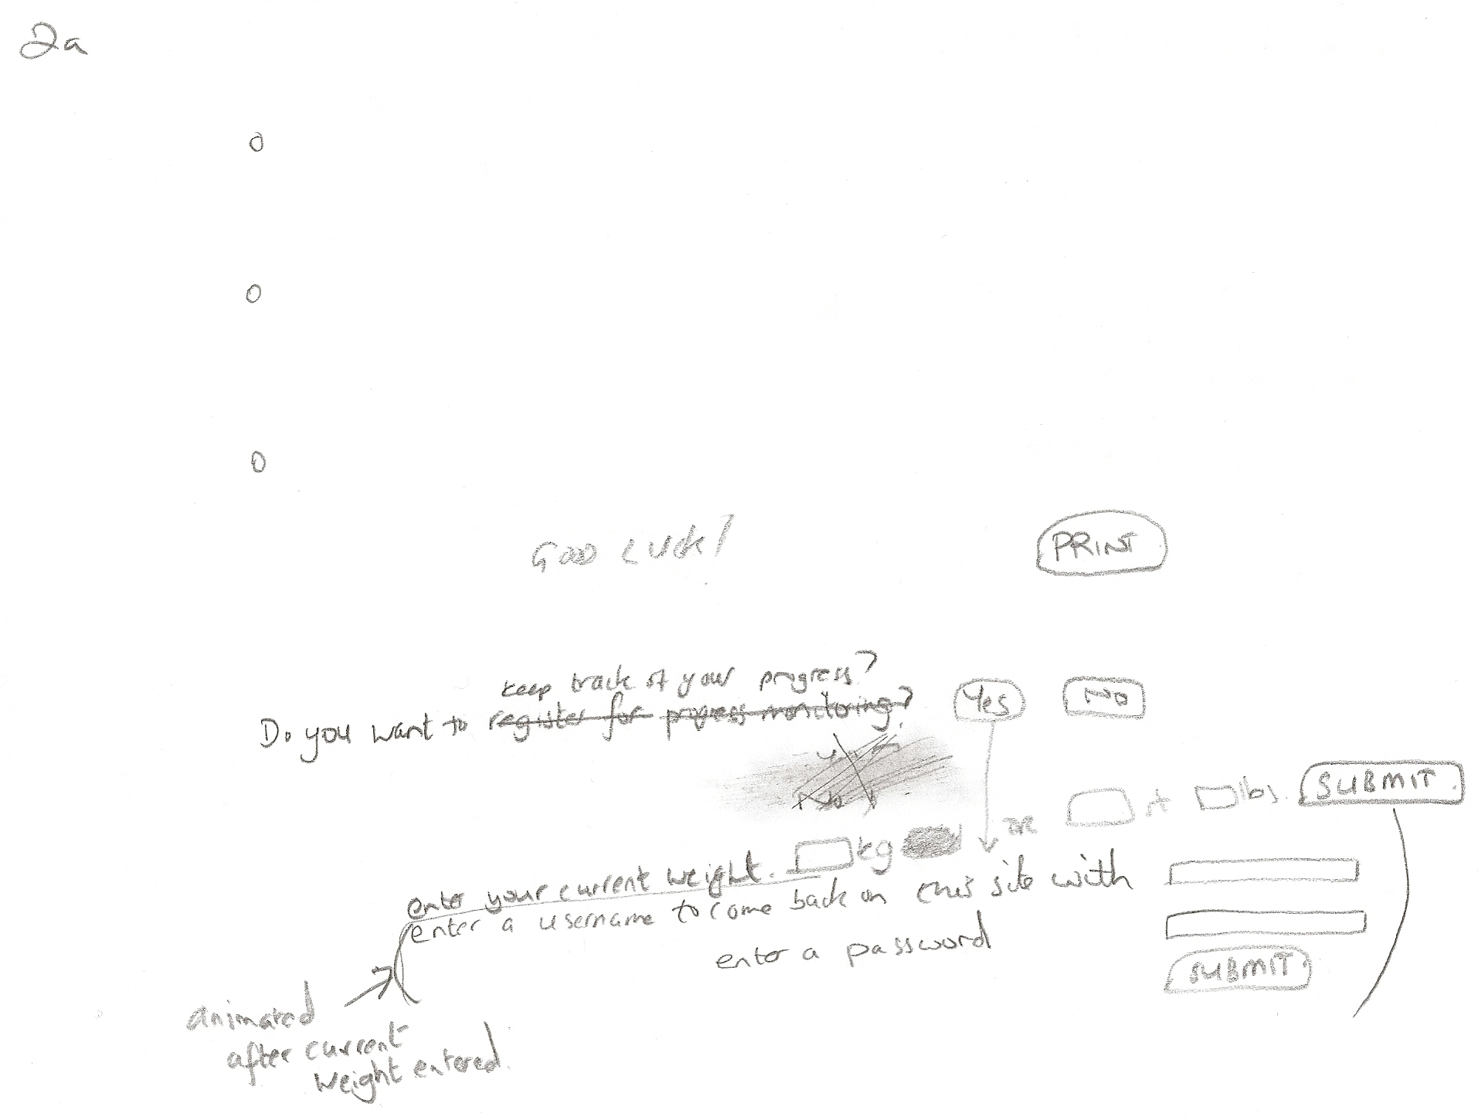

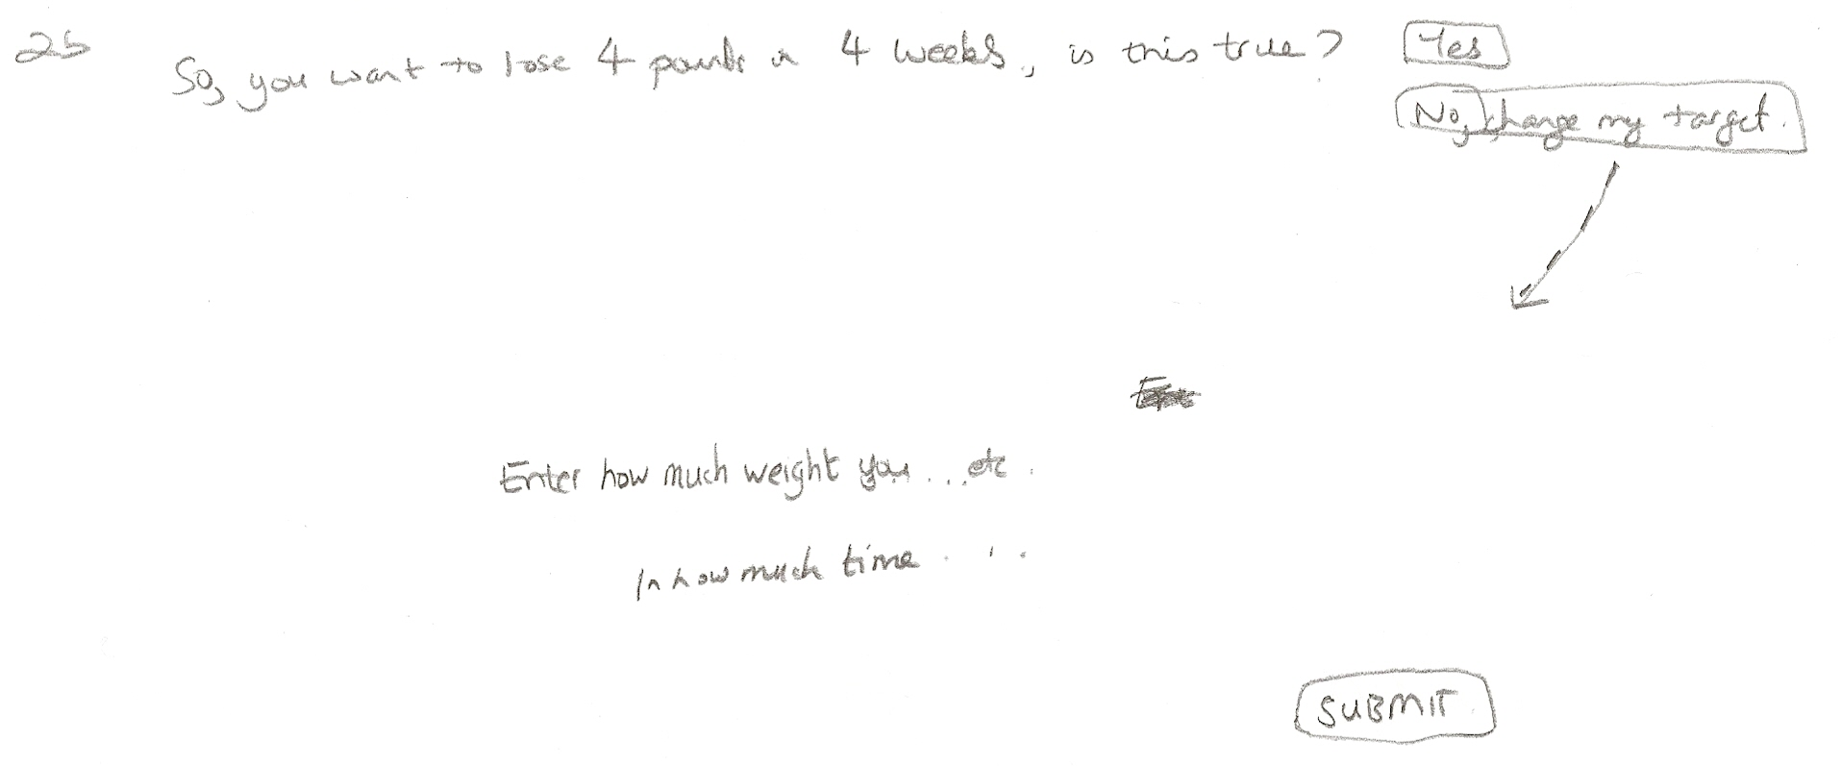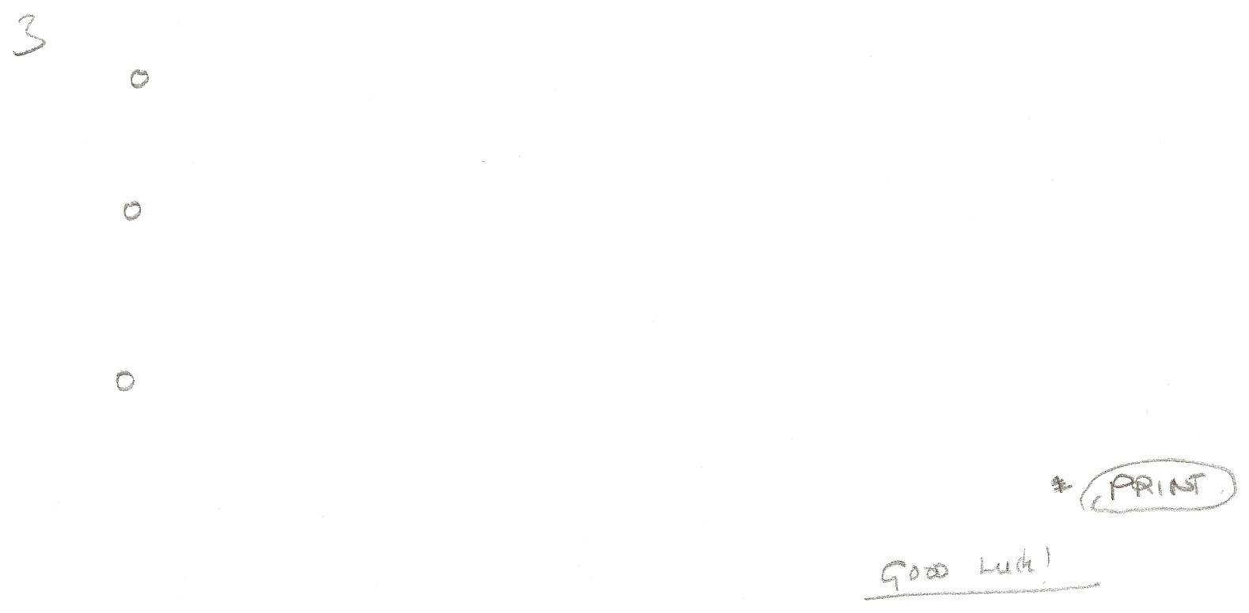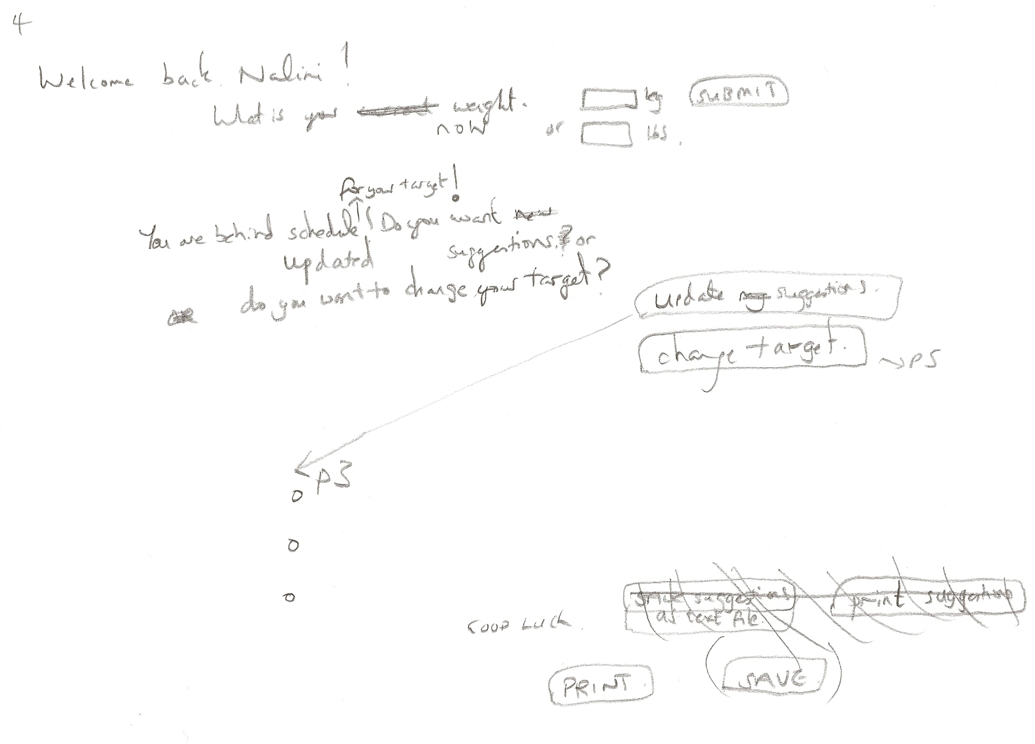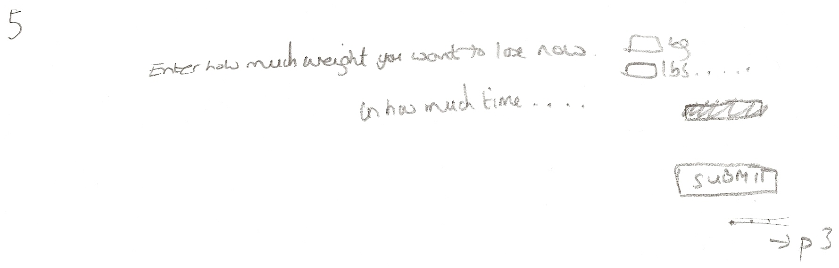 The first page taken from Serif draw plus inside the first page is shown below. Notice how I changed the heading name from the pencil version. I did this because I found “my personalized weight-loss planner” to long a name and a short name is more catchy. Serif Draw Plus is a drawing program for 2D drawings with special effects. I used Serif Draw Plus because it is simple and quick to use.

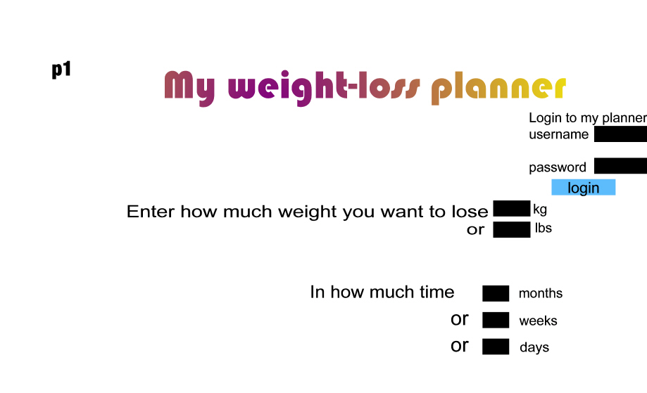
From then on I coded by hand using javaScript for the buttons. Javascript was used also for the fading in and fading out of sections and pages. I am using javaScript to keep everything on the same page and to allow smooth transitions using the functions createElement, RemoveChild and appendChild. I used a WYSIWYG editor first with some hand coding of html to set up the first page and then translated the html into javaScript for dynamic processing.

I decided to use 3D Buttons for visual appeal which changes when you drag the mouse over and changes when the button is pressed. I initially used Fireworks for this then I used 3D button visual editor. Both create 3D buttons.

Fireworks button

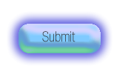Fireworks button

 ‘3D button visual editor’ button

I chose such a simple design with no fancy images or text because I wanted to keep the website simple with no unnecessary information. Sites such as nutracheck.co.uk contain too much information for the user to swallow in one go.

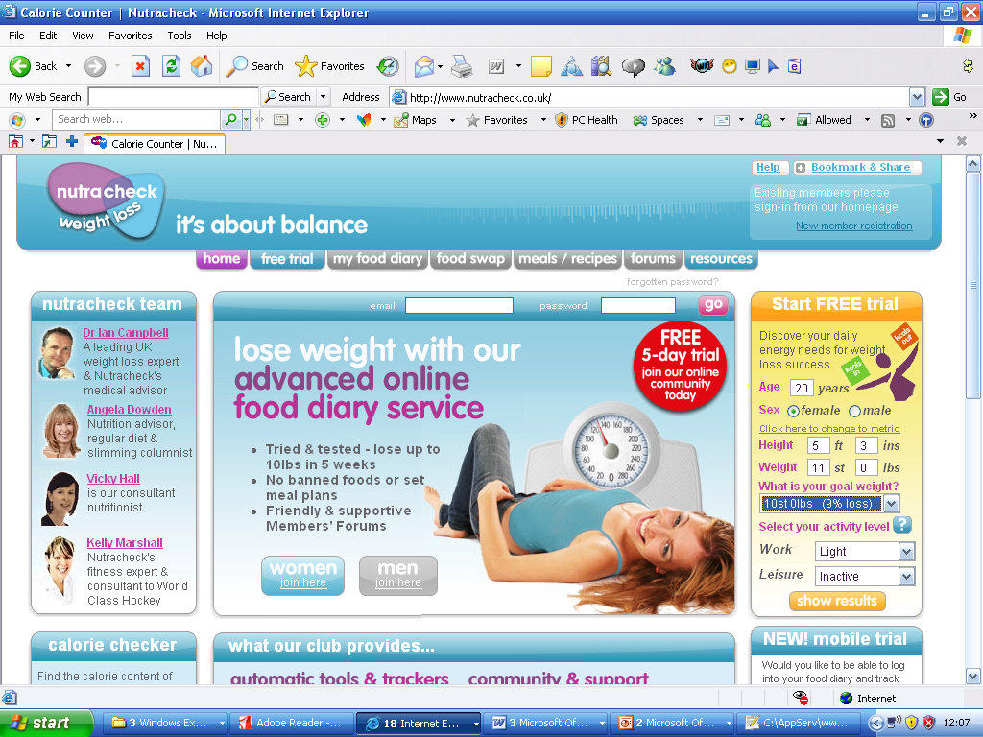
Nutracheck.co.uk

But sites like Google are simple and to the point. I based my site on the simplicity of Google.

Navigation map

Page 1
HOME PAGE
LOGIN
Enter weight to lose and time to lose weight
Page 2
SUGGESTIONS PAGE
ENTER CURRENT WEIGHT
REGISTRATION PAGE
Page 3
Change my target option
Graphical display of target weight and current weight vs time
Page 4 Suggestions list.
Page 5(After login)
Enter weight
Display graph
Tell if behind or ahead of schedule
Update suggestions if necessary.
CHANGE TARGET OPTION
Page 6
Enter weight to lose time to lose weight

Reflection

I have completed the first, second and third page of the site as per my milestones which state that these pages should be finished by 22 February 2009. However I have to complete the page which appears after logging in and all its features and am slightly behind on this. I set this to complete by 15th of March 2009. Page 6 and page 4 won’t take long to complete. But I have to still be careful not to ignore these pages and complete them on time.

A very important milestone of my project is the finishing touches which have to be complete by 26th of March 2009.

The finishing touches include; making a warning if user ends up with unsafe calories to eat or unsafe exercise amount, unsafe amount of weight loss. Make back and forward button work with the javaScript by checking Ajax “back button” articles or using ready made software.

I have already made by website compatible with Mozilla Firefox, Google Chrome, Opera, Safari and internet explorer which is a plus point because this was meant to be one of the finishing touches and I have completed some of the testing early on.

I intend to continually review and, where necessary, improve the design. This may include the layout or the inclusion of dietary advice. This should be finalised by April some time. Then I can get on with the testing during the Easer holidays. I have to work hard not to get behind.

Detailed Thesis Contents

Introduction
This includes a description of the current state of affairs with respect to overweight and obesity, the product description and scope, requirements, aims and objectives and methodology.

Section 1: The Contextual Review
This section includes information on other weight-loss websites, their advantages and disadvantages and how mine can better them. Some references to dietary advice is also given as this may be included in my website.

Section 2: Technical implementation
This section covers the various methods of delivery for my application which include Facebook applications, Adobe AIR, mobile, desktop applications, client-side and server-side deployment. It states why I chose the platforms and methods of delivery I am using for my website.

Section 3:Design and Usability Issues
This section covers some of the issues that need to be addressed about usability when designing my website.

Section 4: Market Survey
This section includes a questionnaire which I handed out to a mixture of 30 people. The answers to the questions give me clues on what I should include in my website.e.g. what to include in my suggestions list.

Section 5.1: Requirements
This section details a list of requirements for my website.

Section 5.2 Design
This sections includes storyboards showing where the elements such as buttons and textboxes of my website will be and navigation of my website. It also describes why I chose such a simple design and states other design features such as graphically representing weight loss progress.

Section 5.3 Gannt chart
This section shows a GANNT chart with all the milestones of my project.

Section 5.4 Testing for Good Usability
This section describes usability guidelines for determining the usability of the website by Jacob Nielson and components of usability by McLaughin and Skinner.
It also includes a testing strategy for my website.

Section 6: Research Study
I will evaluate the findings of my usability/user testing, and any data gathered from test participants.

6. ‘Trial and evaluation’
6.1 Prototype description.
6.2 Pilot study + User selection
6.3 Test results/ interviews = data
6.4 Evaluation.

Section 7: Conclusion
This section is used to bring together and summarise the main points and findings, along with any recommendations.

